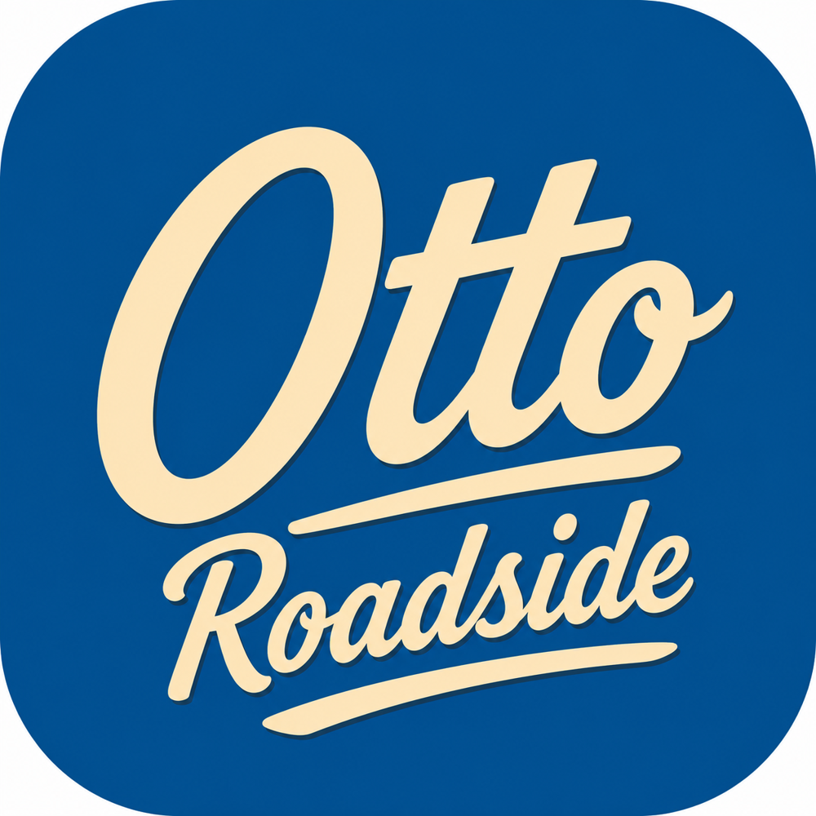
RoadsideOtto
Investor FAQ & Objection Handling
Straight answers to the hard questions — founder prep

Use this to prepare for investor conversations. Answers are honest and grounded in the market research behind our deck and plan. Where we are pre-launch, we say so.
Q1. Isn’t this just Urgent.ly, which struggled?
Urgent.ly proved the demand but ran a capital-intensive, B2B-heavy playbook on a public-market clock, and was acquired by Agero in 2026 for $5.50/share. That validates the category while clearing the field. We’re building a focused, capital-efficient consumer marketplace, one dense metro at a time — a different execution model, not a different thesis.
Q2. How are you different from AAA?
AAA is a prepaid membership club: you pay $65–$139 a year for service capped at ~4 calls, dispatched to contracted tow networks. RoadsideOtto is pay-per-use and on-demand — no annual fee, upfront pricing, the nearest provider tracked to you in real time. We attack the exact value gap: paying for coverage you may never use.
Q3. What stops AAA, Agero, or Uber from doing this?
Incumbents are structurally committed elsewhere: AAA to its membership model and Agero/insurers to white-label B2B — moving to a direct consumer, pay-per-use app creates channel conflict with the partners who pay them today. Uber/Lyft aren’t in roadside. That misalignment is our window; speed and a real consumer brand widen it.
Q4. Marketplaces have a cold-start problem. How do you solve it?
We launch geofenced in one dense metro (Houston’s Harris County core), recruit and vet a base of providers before switching on demand, and concentrate marketing so ETAs stay short. Density is the flywheel: faster response wins drivers, which attracts providers, which improves response. We only expand once the model is proven.
Q5. Untrained civilians working on cars — isn’t that a safety and liability risk?
We scope providers to high-frequency, low-risk tasks (jumps, tire changes, fuel, lockouts) and route complex jobs and tows to professionals. Every provider is identity-verified and background-checked; we carry platform liability coverage, require provider insurance, and build in an SOS button, live trip-share and two-way ratings. Trust & safety is a funded line item (10% of the raise).
Q6. What about insurance and regulation?
Requirements vary by state and service type, which is another reason we go market-by-market. We budget explicitly for insurance, verification and legal, and will partner with established insurers rather than carry all risk ourselves. Phased, local rollout lets us get compliance right before scaling.
Q7. Is a 20% take enough, and can providers really earn well?
At a $90 average job, a 20% take nets ~$18 to the platform (~$15 after processing) — healthy marketplace economics that improve with density. Providers earn ~$72 per job; at 1.3–2 jobs per active hour that’s ~$40–$60+/hr, well above the ~$17–$24/hr typical of rideshare and delivery. Both sides win, which is what makes the marketplace durable.
Q8. Why Houston first?
It’s the largest, hottest, most car-dependent Sunbelt metro — ~7.4M people, ~5.3M vehicles, and extreme heat that drives battery and tire failures — so demand is deep and year-round, without Florida’s hurricane-season shutdown risk. It also has a large gig-labor pool (~3.6M workers) for supply. Big enough to matter, containable enough to win.
Q9. Why now?
Two shifts: the gig economy created the flexible labor force roadside never had (64M freelancers in 2023), and the incumbents just consolidated around B2B (Agero–Urgent.ly, 2026), vacating the consumer lane. The pieces for a consumer on-demand roadside brand exist today in a way they didn’t five years ago.
Q10. What’s your moat?
Local marketplace liquidity (density and ETAs are hard to replicate market-by-market), a trusted consumer brand (Otto) in a category with none, provider supply and ratings data, and switching costs once drivers default to the app. Moats compound with each metro we saturate.
Q11. What traction do you have?
We’re pre-launch by design — brand, business plan and product blueprint are done, and the seed funds the build and Houston launch. We’re not claiming users or revenue we don’t have; the round is explicitly to generate the first proof points and unit-economics data.
Q12. Why this team — and do you have technical leadership?
Ryan Burch brings 22+ years leading complex IT delivery (product vision to shipped software); Brandy Hampton drives operations, risk and growth. A CTO/lead engineer and a Head of Trust & Safety are the first key hires in this round — a deliberate, funded part of the plan, not a gap we’re hiding.
Q13. What are the biggest risks?
Marketplace liquidity in the first market, provider quality/safety at scale, and regulatory/insurance complexity. Our mitigations — geofenced launch, rigorous vetting and coverage, and phased local compliance — are built into the plan and the use of funds. We’d rather name them than paper over them.
Q14. What does the $1.5M get to, and then what?
18–24 months of runway to ship the app, onboard 500+ vetted Houston providers, prove unit economics and retention, launch a second metro, and pilot B2B/fleet — the metrics that support a Series A (~$5–8M) to expand across the Sunbelt.
Q15. What’s the exit?
Roadside is an active M&A category: Agero acquired Urgent.ly, and PE recapitalized HONK — both in 2026. A consumer-scale on-demand network is a natural acquisition target for insurers, automakers, fleets or the incumbents themselves, with the upside of becoming the category-defining consumer brand.
Sources for market figures: Grand View Research, FHWA 2024, Upwork/McKinsey, Agero, U.S. Census/Data USA (see the business plan appendix). Company projections are assumptions, not actuals.

